Application for Individual Counseling Clients

Your full legal name: Date:

Hello and thanks for contacting me. I know it might be challenging to take the first step to reach out for help so kudos to you for asking for support. Let’s discover if we are a good fit.

There are several ways you can get to know me to decide if you would like to work with me. Choose the formats that suit you the best.
- Watch the video on Flourishing-Lives.com Click the “About” tab for credentials, testimonials, and what makes me unique.
- Watch my book video. I talk about the gifts and challenges of being a highly sensitive introvert by vulnerably sharing key moments of my life.
- Read my book, The Gifted Highly Sensitive Introvert, Wisdom for Emotional Healing and Expressing Your Radiant Authentic Self. It’s a memoir and teaching stories to jump-start your learning and to help you determine if you would enjoy working with me.
- Read my websites and blog posts: Flourishing-Lives.com and SensitiveIntrovert.com
- Listen to this meditation: A Journey Into Wholeness – A Guided Meditation MP3 Download. Or purchase a CD. Create a lifestyle with less stress and more inner peace. After meditating, you’ll feel calmer and stronger. You won’t get triggered when people do things you don’t like. Use “A Journey into Wholeness” meditation to create balance in your life. It will help you reduce anxiety and stress, depressed mood, fatigue, pain, insomnia, dis/ease, and irritability. It can also help you repair damaged relationships and increase your self-worth. Make meditation a daily part of your self-care routine.

INFORMATION ABOUT INDIVIDUAL COUNSELING

I see adult clients who are residents of Georgia and North Carolina on Zoom, which is confidential and HIPAA compliant. You’ll need the following:
- a private setting so we can have a confidential session without background noise from people, pets, or devices.
- a stable internet connection.
- Your smartphone, computer or iPad to access Zoom.
- I’ll email Zoom instructions.
Schedule: I see clients Monday-Thursday 10am-6pm Eastern.

For faster progress than 53-minute sessions, consider the following:
- Schedule 80-minute appointments.
- Attend a private personal development retreat.
- Attend an intensive group retreat.
- Combine individual sessions with a weekly HSP group.
- Participate in virtual classes.
Computer Skills: You’ll need to be able to read my Welcome Package forms in a WORD or a PDF document. You’ll need to print forms, sign them, scan them, and return them via email. Or you could mail the forms via USPS if necessary. You’ll need to be able to respond to my emails and/or texts within 24 hours, Monday-Thursday.

No Surprises Act - Good Faith Estimate for private pay individuals
- Intake for individuals @ 53 minutes: $205.
- Intake for individuals @ 80 minutes: $310.00
- Follow-up 53-minute sessions: $180.00
- Follow-up 80-minute sessions: $275.00
Insurance: I am in-network with Anthem BCBS insurance and we will file claims for you. Fees are determined by your insurance contract. To discover what you will owe, contact the member services phone number on your insurance card. Tell them that I use the following codes: 90791 and 90837. Ask about your deductible, copay, or coinsurance. Ask if your policy covers tele-mental health visits. Please tell me what they say.
If you have another insurance carrier, you can use your out-of-network benefits. Contact your insurance to learn how this works. I’ll email you a monthly superbill to give to your insurance company so they can reimburse you.
HOW TO MAKE PAYMENTS: Please make your payment the day before your session or the morning of your session via Venmo. This is the only payment system that I use unless you live outside the USA, in which case I use PayPal. You may pay for multiple sessions at one time if you choose to. You may also mail a check if you prefer.
Health Savings Accounts: Venmo might or might not process health savings account debit cards. You can mail me a check from your HSA account for multiple sessions. Some clients pay me and then get reimbursed by their health savings account. Talk to your employer to learn the rules that apply to you.
CANCELATION POLICY – 48 HOURS: If you can give me a week or more cancelation notice, it is most appreciated because I often schedule clients at least one week ahead of time. I want to fill your time slot if you cancel. Appointments broken within 48 hours must be paid in full before future sessions will be scheduled.
NEWSLETTER: Would you like to receive my email newsletter? I send it at least once every 1 – 2 months. They contain educational articles about relationships, personal growth, holistic healing, and event notices.
__ Yes please, sign me up. __ No thanks.

* * * * * * * * * * * * * * * * * * * * APPLICATION * * * * * * * * * * * * * * * * * * * *

If you would like to work with me, please answer the following questions.

Please return this entire document as an attachment to: Benita@EspositoInstitute.com

Note: This form does not constitute a professional relationship. We’re just getting to know each other.
Take this quiz to see if you score as a highly sensitive introvert. Email me your score, please.

Check all the formats you are interested in:
__ Private sessions via Zoom
__ Highly Sensitive People virtual group
__ Intensive retreats
Referral Source: How did you find me? If you did an internet search, what keywords did you use?
Your full address: street, city, state, country, and zip code
Your email address:
NOTE: If you have a Gmail address, please provide it. Our correspondence will be encrypted and HIPAA-compliant.
Cell phone number: Your age: Date of birth: month/day/year
Please write a brief paragraph for each of the following:
- What is your current situation that you want help with?
- What are your personal and/or professional goals?
- Why would you like to work with me as opposed to other life coaches or therapists.
Do you experience now … or have you ever experienced … any of the following:
- Severe depression, suicidal thoughts or suicidal attempts?
- Have you experienced physical, sexual or emotional abuse or other forms of trauma?
- Do you drink to excess, use drugs without a prescription, or use recreational drugs?
- Do you experience any other addictions, an eating disorder or bipolar symptoms?
- Have you ever attended an in-patient treatment program for emotional or substance abuse issues?
- Have you ever had a psychiatric diagnosis? If so, what?
- Have you ever had legal trouble other than parking tickets? Possible upcoming court cases?

I do not work with clients who have the following conditions: severe depression, suicidal, homicidal, schizophrenia, bipolar disorder, eating disorder, addictions, or borderline personality disorder. You can search for therapists who specialize in these areas on PsychologyToday.com.

Payments:
- What insurance do you have? Please include secondary insurance if you have it.
- Will you be paying out-of-pocket?

If you think we might be a good fit …

- Please email your answers to all these questions to Benita@EspositoInstitute.com.
- I will reply within 48 hours Monday-Thursday. If you don’t hear from me, please contact me again. There might be a technical glitch.
- I offer a complimentary 10-minute Discovery Call Monday-Thursday if we are a good fit. If you want to proceed, please email me with three days and times you can talk on the phone or meet on Zoom. I can usually be available at 12:00 noon or 2:00 pm Eastern.

I look forward to hearing from you soon.
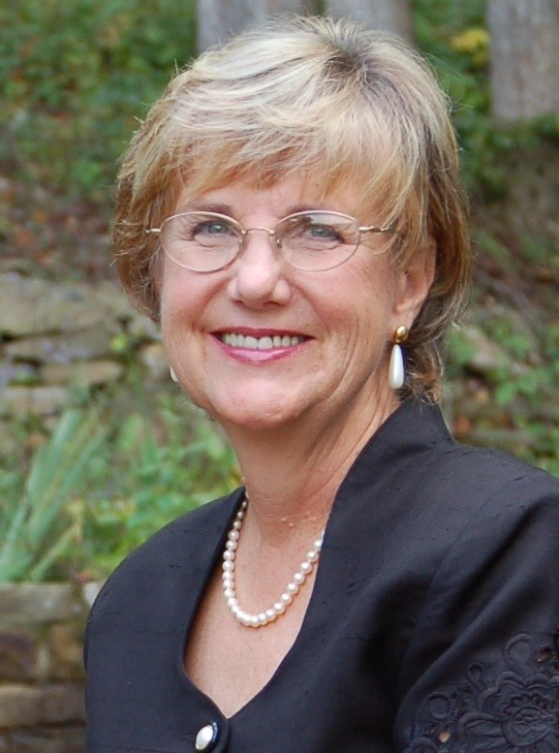
Bright Blessings,
Benita A. Esposito, MA, LPC, LCMHC

Email: Benita@EspositoInstitute.com
Psychotherapy for GA and NC residents
www.Flourishing-Lives.com
Life Coaching and Spiritual Counseling globally
www.SensitiveIntrovert.com

Cell: 770 998 6642
Mail: PO Box 1074, Young Harris, GA 30582

