Information for
Prospective Couples

If you would like counseling, please make a copy of this form so each of you
can complete it separately. Email it to Benita@EspositoInstitute.com.

Please type your full name and today’s date here:

Hello! Thanks for contacting me. This might be a challenging first step so kudos to you for asking for help. It's important for us to do a preliminary exploration to see if we think we are a good fit. I am selective about my clients because my schedule is almost full. Please read the Couples Counseling Protocol for more details.

Please visit my two websites to learn about my services.
- Spiritual Counseling and Life Coaching. You might want to read my book to get to know me. It’s a memoir and teaching stories. The Gifted Highly Sensitive Introvert: Wisdom for Emotional Healing and Expressing Your Radiant Authentic Self. Click here to watch my book video and to take the quiz to see if you are a highly sensitive introvert. This is my specialty area: www.SensitiveIntrovert.com
- Psychotherapy for adults over 21: individuals and couples. Visit www.Flourishing-Lives.com

If my caseload is full, do you want to be added to the waiting list?

What is your age and birthdate?

What is your full address?

What is your email address?

What is your cell phone number?

How did you find me? If you did an internet search, what keywords did you use? Why did you select me to contact?
May I ask you a few questions to see if we are a good fit?
Please write three brief paragraphs.
- Describe your current situation.
- Describe your goals.
- What makes your relationship fighting for?

Do you experience now … or have you ever experienced … any of the following?
- Severe depression, suicidal thoughts or suicidal attempts?
- Do you experience too much stress or anxiety?
- Do you experience physical, sexual or emotional abuse or other forms of trauma?
- Do you drink to excess, or use drugs without a prescription, or use recreational drugs?
- Do you have other addictions, or an eating disorder … past or present?
- Have you ever attended an in-patient treatment center for mental, emotional or substance abuse issues?
- Have you ever had a psychiatric diagnosis? If so, what?
- Legal trouble other than parking tickets. Possible up-coming court cases?

DISTANCE COUNSELING on ZOOM
- I only see clients on Zoom which is HIPAA compliant.
- You must be in a private setting so we can have a confidential session. It must be a quiet environment without sounds of children, pets, etc.
- You need a stable internet connection on your smartphone, computer or iPad.
- Is Zoom going to work for you?
SCHEDULE: I see clients Monday-Thursday 10am-6pm Eastern. After the first four sessions which comprise the Assessment Phase, we will schedule 80-minute appointments. My last session begins at 5pm during warm weather months and 6pm during the winter.

Does this schedule work for you? When are you available?

COMPUTER SKILLS
You need to be able to read my Welcome Package and Intake form in a WORD or a PDF document. You’ll return them via email or fax. You need to be able to respond to my emails within 24-48 hours.
Can you do that?
FEES
Will you be paying out-of-pocket? Or, do you have Anthem BCBS? Do my fees work for you?

Self-Pay Fees for Psychotherapy
Individual intake visit @ 53 minutes: $200.00 Couples intake visit @ 53 minutes: $235.00
Individual intake visit @ 80 minutes: $300.00 Couples intake visit @ 80 minutes: $350.00

Individual follow-up visit @ 53 minutes: $175.00 Couples follow-up @ 53 minutes: $195.00
Individual follow-up visit @ 80 minutes: $265.00 Couples follow-up @ 80 minutes: $295.00

If you use Anthem BCBS insurance, I can probably process your BCBS insurance for individual sessions if you are a resident of Georgia or North Carolina, but not other states. Insurance does not cover marriage counseling or couples counseling. There are two individual sessions in the Assessment Phase, one for you and one for your partner. I am out of network with all other insurance companies. I can give you a receipt to submit to your insurance so they can reimburse you. I do not process Medicare or Medicaid or EAP’s.

To research your Anthem BCBS fee for individual sessions, contact the member phone number on your card and ask the following questions about outpatient mental health office visits. Please send me your answers.
- What’s the deductible amount and how much has been met for the year?
- When does the calendar year begin for your insurance?
- Is the fee the same for medical and mental health services?
- What is the amount of co-pay or co-insurance after the deductible has been met?
- These is my CPT code: 90837. I am a mental health specialist: LPC in GA and LCMHC in NC.
- Does your policy cover telemental health? I only offer sessions via Zoom video-conferences which are HIPAA compliant.
- *** Insurance companies have the right to review your therapy notes if they choose to. Your diagnosis will stay on your record. If you don’t want that to happen, do not use insurance.

HOW TO MAKE PAYMENTS
Please make your payment the day before your session via PayPal. This is the only payment system that I use. I’ll send instructions if we decide to work together. You may pay for multiple sessions at one time if you choose to.
Health Savings Accounts: PayPal cannot process health savings account debit cards. You can mail me a check from your HSA account for multiple sessions. Some clients pay me and then get reimbursed by their health savings account. Talk to your employer to learn the rules that apply to you.
Does PayPal work for you? Or, would you like to mail a check?
CANCELATION POLICY
Please give me at least one week cancelation notice if possible. This is most appreciated because I schedule clients a week ahead of time, and I want to be able to fill your cancelled time slot. Appointments broken within 48 hours are charged at the full rate and must be paid in full before future sessions will be scheduled.
Does this cancelation policy work for you?
CLIENT PORTAL
You’ll have access to my electronic calendar on the Client Portal so you can schedule appointments at your convenience. You will be able to use encrypted HIPAA-compliant email. If you have Gmail, my Gmail to your Gmail is HIPAA-compliant.
Does this work for you?
NEWSLETTER: Would you like to receive my email newsletter? I send one about every 1 – 2 months. They contain educational articles about relationships, personal growth, holistic healing, and notices of events.
__ Yes __ No thanks.

If you think we might be a good fit …
- I ask that each of you email this completed form to me. Email: Benita@EspositoInstitute.com. Each of you will return a separate questionnaire.
- I’ll usually reply within 48 hours, Mon-Thur. If you don’t hear from me, please contact me again.
- I offer a complimentary 10-minute Discovery Call Monday-Thursday at 9:30am or 2-3pm Eastern. Please email me with three days and times that you are available.
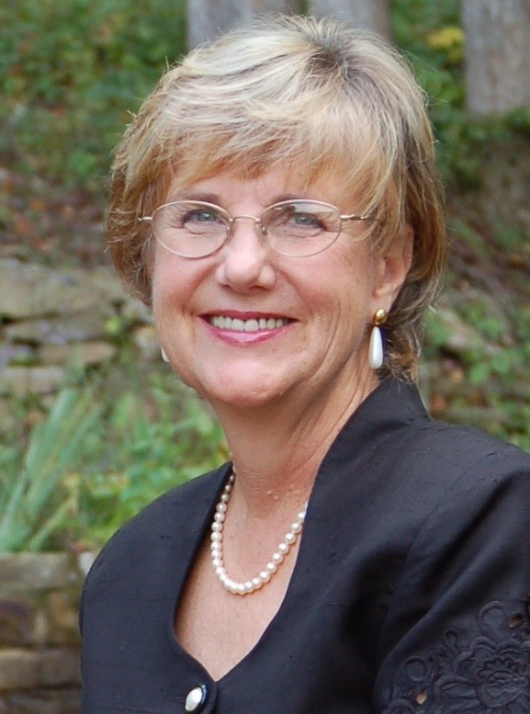
I look forward to hearing from you soon.

Bright Blessings,
Benita A. Esposito, MA, LPC, LCMHC
Licensed in Georgia and North Carolina
Cell: 770 998 6642
E: Benita@EspositoInstitute.com

