Information for
Prospective Psychotherapy Clients

Please type your full name and the date here:

Hello! Thanks for contacting me. This might be a challenging first step so kudos to you for asking for help. It's important for us to do a preliminary exploration to see if we both think we are a good fit. I'm not right for everyone, and I am selective about my clients because my schedule is almost full.

Please visit my two websites to learn about my services.
- Psychotherapy for individual and couples over 21: www.Flourishing-Lives.com.
Read about my credentials, theory and techniques. https://www.flourishing-lives.com/how-i-help/

- Spiritual Counseling and Life Coaching for Highly Sensitive Introverts. Watch my book video and take the quiz to see if you are a highly sensitive introvert. Counseling Highly Sensitive People is my specialty area. You might want to read my book to decide if we are a good fit. The book consists of my memoir and teaching stories to accelerate your journey. Click: www.SensitiveIntrovert.com

May I ask you a few questions to see if we are a good match?

What is your age and your birthdate?

What is your full address?

What is your cell phone number?

How did you find me? If you did an internet search, what keywords did you use? Why did you select me to contact instead of thousands of other therapists?
Please write two brief paragraphs describing your current situation and your goals.
Do you experience now … or have you ever experienced … any of the following:
- Severe depression, suicidal thoughts or suicidal attempts?
- Do you experience too much stress or anxiety?
- Do you experience physical, sexual or emotional abuse or other forms of trauma?
- Do you drink to excess, or use drugs without a prescription, or use recreational drugs?
- Do you have other addictions, or an eating disorder … past or present?
- Have you ever attended an in-patient treatment center for mental, emotional or substance abuse issues?
- Have you ever had a psychiatric diagnosis? If so, what?
- Legal trouble other than parking tickets. Possible up-coming court cases?

DISTANCE COUNSELING
I only see clients on Zoom. My account is encrypted and HIPAA compliant.
- You must be in a private setting so we can have a confidential session. It must be a quiet environment without sounds of children, pets, etc.
- You need a stable internet connection on your smartphone, computer or iPad.
- I’ll email Zoom instructions.
- Is Zoom going to work for you?

SCHEDULE: I see clients Monday-Thursday 10am-7pm Eastern during the winter months, and 10am-6pm Spring-Fall. Sessions are 50-53 minutes. For faster progress, you may schedule an 80-minute appointment at 1pm or in the evening.

When you are available?

Does this schedule work for you?

COMPUTER SKILLS: You need to be able to read my Welcome Package and Intake form in a WORD document or a PDF. You need to be able to respond to my emails within 24-48 hours.
Can you do this?
FEES
Will you be paying out-of-pocket?
Self-Pay Fees for Psychotherapy
Individual intake visit @ 53 minutes: $200.00 Couples intake visit @ 53 minutes: $200.00
Individual intake visit @ 80 minutes: $300.00 Couples intake visit @ 80 minutes: $320.00

Individual follow-up visit @ 53 minutes: $165.00 Couples follow-up @ 53 minutes: $185.00
Individual follow-up visit @ 80 minutes: $247.00 Couples follow-up @ 80 minutes: $275.00

Anthem BCBS is the only insurance panel I’m on. I will submit claims for you. Insurance does not cover couple counseling. I can probably process your BCBS insurance if you are a resident of Georgia or North Carolina, but not other states. I am out of network with all other insurance companies. I can give you a receipt to submit to your insurance so perhaps they can reimburse you. I do not process Medicare or Medicaid or EAP’s.
Your BCBS fee is the allowable rate indicated on the insurance EOB (Explanation of Benefits). The fee is a contract between you and your insurance company. To research your fee, call your insurance company and ask the following questions about outpatient mental health office visits:
- What’s the deductible amount and how much has been met for the year?
- When does the calendar year reset for your insurance?
- Is the deductible and copay the same for medical and mental health services?
- What is the amount of co-pay or co-insurance after the deductible has been met?
- These are my CPT codes: 90791 and 90837. I am a mental health specialist: LPC in GA, LCMHC in NC.
- Does your policy cover telemental health? I only offer sessions via Zoom video-conferences which are HIPAA compliant.
- *** Insurance companies have the right to review your therapy notes if they choose to. Your diagnosis will stay on your record. If you don’t want that to happen, do not use insurance.
Do my fees work for you?
Do you have BCBS or will it be self-pay? Which one?

HOW TO MAKE PAYMENTS: Please make your payment the day before your session via PayPal. This is the only payment system that I use. I’ll send instructions if we decide to work together. You may pay for multiple sessions at one time if you choose to.
Note about Health Savings Accounts: PayPal cannot process health savings account debit cards. You can mail me a check from your HSA account for multiple sessions. Some clients pay me and then get reimbursed by their health savings account. Talk to your employer to learn the rules that apply to you.
Does PayPal work for you?
CANCELATION POLICY: Give me a week or more cancelation notice if possible. This is most appreciated because I schedule clients a week ahead of time, and I want to be able to fill your cancelled time slot. Appointments broken within 48 hours must be paid in full before future sessions will be scheduled.
Does this work for you?
CLIENT PORTAL: You’ll need to set up an account on my Client Portal. It allows you to access my electronic calendar so you can schedule your appointments and use encrypted HIPAA-compliant email.
Does this work for you?

NEWSLETTER: Would you like to receive my email newsletter? I send one about every 1 – 2 months. They contain educational articles about relationships, personal growth, highly sensitive people, holistic healing, and notices of events.
__ Yes, please __ No thanks.

If you think we might be a good fit …
- Please email all your answers to these questions to Benita@EspositoInstitute.com.
- If you want couple counseling, each of you should return a separate questionnaire.
- I’ll reply within 48 hours Monday-Thursday. If you don’t hear from me, please contact me again.
- I offer a complimentary 10-minute Discovery Call Monday-Thursday at 9:30am or 2pm EASTERN. If you want an appointment, please email me three days and times that you are available.

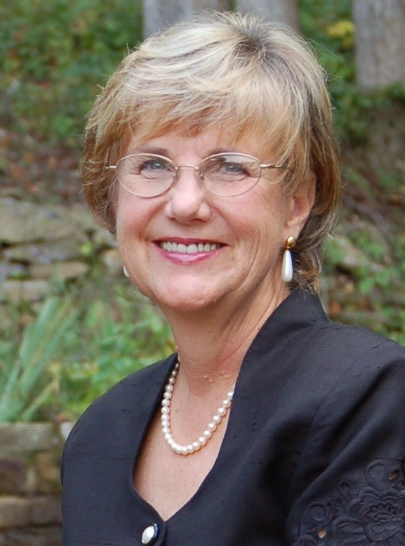
I look forward to hearing from you soon.

Bright Blessings,

Benita A. Esposito, MA, LPC, LCMHC

Licensed in Georgia and North Carolina

C: 770 998 6642

E: Benita@EspositoInstitute.com

